A Guide to Determining Correct Python Syntax for Modifying Properties on Paraview

By: Jacob Kowalski

Overview: This is a follow-up guide to my previous guide on automatically producing movies and images from OpenFoam data using only python script. The code runs through all the steps you would in the paraview interface, and because of this the paraview interface can be used to determine the correct python code for altering any property. As I did not cover absolutely everything you can change, this short guide will provide a format for quickly determining the code needed to change any property

Step 1: Open paraview on your computer (preferably the same version you will be using later on) and create any object/image. For this example I’ll start with a simple sphere.

Step 2: Go to Tools and select Start Trace. You will be presented with the following window:

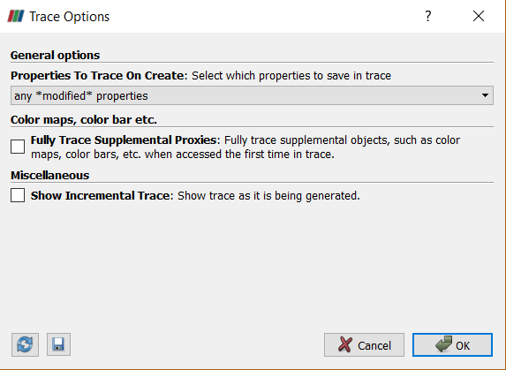You should use the options as shown, although changing “any \*modified\* properties” to “all properties” will work but also display code for properties you didn’t change and can therefore be confusing.

Step 3: Change the properties that you want to be able to adjust in the python automation code. For example take a clip of a sphere and then change the image to display as a wireframe. Afterwards go back to Tools and select Stop Trace. Something like the following should display:

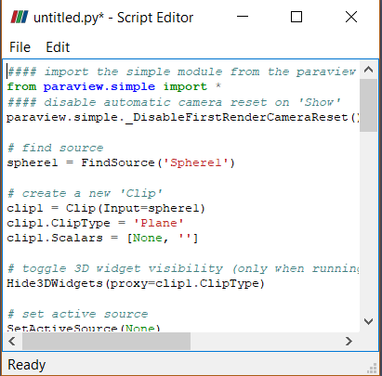

This script editor contains python code that if executed in the python shell on paraview would produce the image being shown. While some of the code may be redundant compared to what is already in the python automation scripts, but the code for changing the image to display as a wireframe can pretty easily be identified.



Then, an appropriately modified line of code can be introduced into the already created python script to make this change. It’s a pretty simple process, the only trick can sometimes be identifying which lines of code you will need to make the change.